PICK PMR Insights Collective Tool

PICK-PMRTest plan

Version 0.2

4/28/20

Document Control

Approval

The Guidance Team and the customer shall approve this document.

Document Change Control

|  |  |
| --- | --- |
| Initial Release: | 0.1 |
| Current Release: | 0.2 |
| Indicator of Last Page in Document: | & |
| Date of Last Review: | 04/28/2020 |
| Date of Next Review: |  |
| Target Date for Next Update: | 05/08/2020 |

Distribution List

This following list of people shall receive a copy of this document every time a new version of this document becomes available:

Guidance Team Members:

Jake Lasley

Steven Roach

Customer:

Dr. Oscar Perez

Vincent Fonseca

Herandy Denisse Vazquez

Baltazar Santaella

Florencia Larsen

Erick De Nava

Software Team Members:

Jay James

Cristian Molina

Sergio Nogami

Adrian Sosa

Jesus Gomez

Change Summary

The following table details changes made between versions of this document

|  |  |  |  |
| --- | --- | --- | --- |
| Version | Date | Modifier | Description |
| 0.1 | 4/15 | Everyone | First draft of the Test Plan |
| 0.2 | 4/27 | Everyone | Final version of Test Plan |
|  |  |  |  |

Note: The template presented in this document was taken from:

Donaldson, S., and S. Siegel, *Successful Software Development*. Upper Saddle River, NJ: Prentice Hall, 2001, pp. 321-323.

Note: The template presented in this document was taken from: Donaldson, S., and S. Siegel, *Successful Software Development*. Upper Saddle River, NJ: Prentice Hall, 2001, pp. 321-323 and modified by Humberto Mendoza and Steve Roach.

Supplementary information is from:

Pfleeger, S. *Software Engineering, Theory and Practice*. Upper Saddle River, NJ: Prentice Hall, 1998, p. 365.

Table of Contents

Document Control ii

Approval ii

Document Change Control ii

Distribution List ii

Change Summary ii

1. Introduction 1

1.1. Purpose 1

1.2. Scope 1

1.3. System Overview 1

1.4. Suspension and Exit Criteria 2

1.5. Document Overview 2

1.6. References 2

2. Test Items and Features 3

3. Testing Approach 3

4. Test System Configuration 6

4.1. Test Create Event Configuration 6

4.2. Test Create Team Configuration 8

4.3. Test Select Directory Configuration 9

5. Test Log file Configuration 11

5.1. Test Sort Log Files 11

5.2. Test View Enforcement Action Report 11

6. Test log entry Configuration 12

6.1. Test Sort Entries 13

6.2. Test filter Entries 14

6.3. Test flag Entries 15

7. Test graph Configuration 16

7.1. Test Add Node 16

7.2. Test edit Node 17

7.3. Test delete Node 18

7.4. Test Add Relationship 19

7.5. Test edit Relationship 20

7.6. Test delete Relationship 21

7.7. Test export graph 22

8. Test Enforcement Action Report Configuration 24

8.1. Test View errors 24

8.2. Test Re-Validate 24

8.3. Test Ingest despite Errors 25

9. Test Vector Configuration 27

9.1. Test Add Vector 27

9.2. Test Delete Vector 27

9.3. Test Update Pull Vector 28

9.4. Test Edit Vector Atrributes 29

9.5. Test Commit Vector 30

9.6. Test Approval Commit Vector 31

10. Test Schedule 33

11. Appendix 35

# Introduction

The purpose, scope, system overview, test approach overview, document overview, and references will be found in this section.

## Purpose

The purpose of the Test Plan document is to provide detailed information of the testing approach and schedule conducted for the PICK-PMR Insight Collective Knowledge (PICK). This document represents the ultimate review of the Software Requirements Specification Document (SRS), the Software Design Document (SDD) and the code used to implement the system. The purpose is to verify that the functionality of the PICK system works according to the requirements specified by the client.

The intended audience for the Test Plan is the following:

**Guidance Team Members:**

Jake Lasley

Steven Roach

**Customer:**

Dr. Oscar Perez

Vincent Fonseca

Herandy Denisse Vazquez

Florencia Larsen

Erick De Nava

**Software Team Members:**

Jay James

Adrian Sosa

Cristian Molina

Sergio Nogami

Jesus Gomez

## Scope

|  |  |  |
| --- | --- | --- |
| **Version** | **Release Date** | **Description** |
| 1.0.0 | 2/6/20 | First GUI version |
| 1.1.0 | 2/20/20 | Added Filter Configuration |
| 1.2.0 | 3/5/20 | Integrated Splunk |
| 1.3.0 | 4/2/20 | Added transcription, cleansing and validation |
| 1.4.0 | 4/16/20 | Added Graph |
| 1.5.0 | 4/28/20 | Added all missing test suites along with their test cases. |

## System Overview

The Lethality Survivability & Human Systems Integration Directorate (LSH) works with the Department of Defense (DOD) to perform operational testing on technology systems to provide secure, resilient capabilities in the expected operational environment. The LSH or White team will analyze the flow of events that occurred during adversarial attacks between the Red and Blue teams to validate what happened during the attack. The Red team performs the attacks and the Blue team tries to mitigate them. The scope of PICK PMR Insights Collective tool will cover the need of the LSH to draw relationships between the events that occurred between the Red and Blue teams. The PMR tool will not draw the correlation of events itself but rather ease the process of drawing the correlations for the analyst.

## Suspension and Exit Criteria

This section provides a detailed, unambiguous description of when the team plans to stop testing, either due to the finding of several critical bugs where further testing would be undesirable or by the code passing all required tests.

**Suspension Criteria:**

More than one critical test fails

More than 50% of non-critical tests fail

**Exit Criteria:**

All tests are run

All critical tests pass

90% of non-critical tests pass

## Document Overview

* Section 1 introduces the test plan and the purpose of the system.
* Section 2 describes the test items such as components, classes and functions of the system and the features to be tested.
* Section 3 describes the approach in detail that will be used in each test case.
* Section 4 contains all the test cases for the test suite System Configuration.
* Section 5 contains all the test cases for the test suite Log File Configuration.
* Section 6 contains all the test cases for the test suite Log Entry Configuration.
* Section 7 contains all the test cases for the test suite Graph Configuration.
* Section 8 contains all the test cases for the test suite Enforcement Action Report.
* Section 9 contains all the test cases for the test suite Vector Configuration.
* Section 10 contains the test schedule which has the completion dates for each testing activity.
* Section 11 Appendix.

## References

[1] ￼Elsa Tai (2018), “Prevent, Mitigate, and Recover (PMR) Insight Collective Knowledge System (PICK)

Software Requirements Specification ” UTEP, Sept 2020.

[2] O. Perez et al, Requirements Definition Document, Lethality, Survivability and HSI Directorate, 2019

# Test Items and Features

The following items are features to be tested in the system.

|  |  |  |
| --- | --- | --- |
| **Test Case ID** | **Item/Feature** | **Item/Feature Description** |
| SC1 | **Create Event Configuration** | Enter name, description, and timestamp range of an event. |
| SC2 | **Create Team Configuration** | Establish connection to the server. |
| SC3 | **Select Directory Configuration** | Choose directories to be ingested into the system. |
|  |  |  |
| LFC1 | **Sort Log Files** | Sort log files by a specific attribute. |
| LFC2 | **View Enforcement Action Report** | Display line numbers where ingestion errors occur in a log file as well as why they failed. |
|  |  |  |
| LEC1 | **Sort Entries** | Sort log entries by a specific attribute. |
| LEC2 | **Filter Entries** | Filter log entries by multiple attributes. |
| LEC3 | **Flag Entries** | Associate logs to a vector |
|  |  |  |
| GC1 | **Add Node** | Adds a node to graph. |
| GC2 | **Edit Node** | Edits details of the node. |
| GC3 | **Delete Node** | Deletes a node from the graph. |
| GC4 | **Add Relationship** | Adds a relationship between two nodes on the graph. |
| GC5 | **Edit Relationship** | Edits the relationship properties. |
| GC6 | **Delete Relationship** | Removes a relationship between two nodes. |
| GC7 | **Export Graph** | Exports an image of the graph in the desired format. |
|  |  |  |
| EAR1 | **View Errors** | Displays lines numbers and error messages in a log file. |
| EAR2 | **Re-Validate** | Checks if a log file meets validation criteria. |
| EAR3 | **Ingest Despite Errors** | Ingests log file with errors. |
|  |  |  |
| VC1 | **Add Vector** | Adds a new vector to the vector table. |
| VC2 | **Delete Vector** | Removes a vector from the vector table. |
| VC3 | **Update Pull Vector** | Updates vector table with changes pushed to the vector database. |
| VC4 | **Edit Vector Attributes** | Changes attributes of a given vector. |
| VC5 | **Commit Vector** | Submits the vector changes to be approved by the analyst. |
| VC6 | **Approval Commit Vector** | Approve changes made to a vector. |

# Testing Approach

This section describes the testing approach of the system and shall provide an explanation of the kinds of testing the team plans to use to ensure the PICK-PMR Insight Collective Knowledge system works as the users expect it to behave.

**3.1 System Testing**

System testing is the follow-up of integration testing. Once all the components have been unit tested and integration tested, there will be a focus on testing the entire system through system testing. This is where we tested the main components of the system. In the team’s case, the requirements for the demo were followed to ensure that they functioned the way that the guidance team and our clients expect.

Table 1: System Configuration Test Plan

|  |  |  |
| --- | --- | --- |
| * **TEST SUITE: System Configuration** | | |
| **Description of Test Suite** | This test suite contains the test cases for the components of Event Configuration section of the PICK System. | |
| **Test Case Identifier** | **Objective** | **Criticality** |
| SC1 | **Create Event Configuration** | **Normal** |
| SC2 | **Create Team Configuration** | **Normal** |
| SC3 | **Select Directory Configuration** | **Normal** |

**Table 2: Log File Configuration**

|  |  |  |
| --- | --- | --- |
| * **TEST SUITE: Log File Configuration** | | |
| **Description of Test Suite** | This test suite contains the test cases for the components of the Log File Configuration. | |
| **Test Case Identifier** | **Objective** | **Criticality** |
| LFC1 | **Sort Log Files** | **Normal** |
| LFC2 | **View Enforcement Action Report** | **Normal** |

**Table 3: Log Entry Configuration**

|  |  |  |
| --- | --- | --- |
| * **TEST SUITE: Log Entry Configuration** | | |
| **Description of Test Suite** | This test suite contains the test cases for the components of the Log Entry section of the PICK System. | |
| **Test Case Identifier** | **Objective** | **Criticality** |
| LEC1 | **Sort Entries** | **Normal** |
| LEC2 | **Filter Entries** | **Normal** |
| LEC3 | **Flag Entries** | **Critical** |

Table 4: Graph Configuration

|  |  |  |
| --- | --- | --- |
| * **TEST SUITE: Graph Configuration** | | |
| **Description of Test Suite** | This test suite contains the test cases for the components of the Graph Configuration Page of the PICK System | |
| **Test Case Identifier** | **Objective** | **Criticality** |
| GC1 | **Add Node** | **Critical** |
| GC2 | **Edit Node** | **Critical** |
| GC3 | **Delete Node** | **Critical** |
| GC4 | **Add Relationship** | **Critical** |
| GC5 | **Edit Relationship** | **Critical** |
| GC6 | **Delete Relationship** | **Critical** |
| GC7 | **Export Graph** | **Critical** |

Table 5: Enforcement Action Report Test Suite

|  |  |  |
| --- | --- | --- |
| * **TEST SUITE: Enforcement Action Report** | | |
| **Description of Test Suite** | This test suite contains the test cases for the components of the Enforcement Action Report of the PICK System | |
| **Test Case Identifier** | **Objective** | **Criticality** |
| EAR1 | **View Errors** | **Normal** |
| EAR2 | **Re-Validate** | **Normal** |
| EAR3 | **Ingest Despite Errors** | **Normal** |

Table 6: Vector Configuration Test Suite

|  |  |  |
| --- | --- | --- |
| * **TEST SUITE: Vector Configuration** | | |
| **Description of Test Suite** | This test suite contains the test cases for the components of the Vector Configuration of the PICK System | |
| **Test Case Identifier** | **Objective** | **Criticality** |
| VC1 | **Add Vector** | **Critical** |
| VC2 | **Delete Vector** | **Critical** |
| VC3 | **Update Pull Vector** | **Critical** |
| VC4 | **Edit Vector Attributes** | **Critical** |
| VC5 | **Commit Vector** | **Normal** |
| VC6 | **Approval Commit Vector** | **Critical** |

# System Configuration

This section contains a set of tests for the System Configuration components.

## 4.1 Create Event Configuration

|  |  |  |  |  |  |  |
| --- | --- | --- | --- | --- | --- | --- |
| Test No.: SC1 | | | | Current Status: Pending | | |
| Test title: Create Event Configuration | | | | | | |
| Testing approach: In order to complete this test the user must be in the Event Configuration window. | | | | | | |
| STEP  1.  2.  3.  4.  5. | OPERATOR ACTION  The operator enters a name in the Event Name text field. Example Input: “Event name”  The operator enters a description under the Event Description text field. Example Input: “Entering a sentence describing the event is the content in this text field.”  The operator enters a start timestamp by selecting a date and time from the Event Start Date calendar. Example Input: “12/01/99 2:55 PM ”  The operator enters an end timestamp by selecting a date and time from the Event End Date calendar. Example Input: “12/01/99 2:55 PM ”  The operator clicks Save Button. | PURPOSE  To ensure that Event Name is a string excluding non-alphabetical characters.  To ensure that Event Description is a string excluding non-alphabetical characters.  To ensure that the timestamp is valid and to ensure that the timestamp follows the specified format.  To ensure that the timestamp is valid, to ensure that the timestamp follows the specified format, and to ensure the end timestamp is after start timestamp.  To ensure that previous input follows the format specified. | | | EXPECTED RESULTS  The system displays the characters entered under the text field “Event Name:”  The system displays the characters entered under the text field “Event Description:”  The system displays the timestamp in the text field Event Start Date as “MM/DD/YY HH : mm ss”  The system displays the timestamp in the text field Event End Date as “MM/DD/YY HH : mm ss”  The system displays “Event Timestamp Validated” in green text. | COMMENTS |
| Concluding Remarks: Pending | | | | | | |
| Testing Team: Pending | | | Date Completed: Pending | | | |

## 4.2 Create Team Configuration

|  |  |  |  |  |  |  |
| --- | --- | --- | --- | --- | --- | --- |
| Test No.: SC2 | | | | Current Status: Pending | | |
| Test title: Create Team Configuration | | | | | | |
| Testing approach: In order to complete this test, the user must be in the event configuration window and a Splunk account must exist. | | | | | | |
| STEP  1.  2.  3.  4.  5.  6.  7. | OPERATOR ACTION  The operator enters the lead IP Address. Example Input: “10.10.20.250”.  The operator enters the port to connect. Example Input: ”98”.  The operator enters index Example Input: “Any String”.  The operator enters username Example Input: “Any string”.  The operator enters password Example Input: “Any string”.  The operator checks the lead IP box.  The operator clicks Connect.  . | PURPOSE  Operator must specify what machine it is connecting to.  Operator must specify what port to connect to.  Operator must specify what index to connect to,  Operator must specify a username to log in to the Splunk server.  Operator must specify a password that corresponds to username to log in to the Splunk server  Operator must check the lead IP box to operate as the lead.  The operator must click the button labeled “Connect” to establish a connection to the Splunk server. | | | EXPECTED RESULTS  The text field labeled “Lead IP Address” should display the IP Address entered.  The text field labeled “port” should display the port number entered.    The text field labeled “Splunk index” should display the name of the Splunk index entered.  The text field labeled “Username” should display the entered username.  The text field labeled “Password” should display the entered password as a sequence of black dots.  The checkbox labeled “Lead” should display a checkmark.  A connection will be established to the Splunk Server for the credentials  Established connections will increase or decrease accordingly when operators connect or disconnect. If 20 operators are connected, an error message stating the limit of connections is reached will be displayed. | COMMENTS  Lead IP indicator must display for the lead IP host’s window. |
| Concluding Remarks: Pending | | | | | | |
| Testing Team: Pending | | | Date Completed: Pending | | | |

## 4.3 Select Directory Configuration

|  |  |  |  |  |  |  |
| --- | --- | --- | --- | --- | --- | --- |
| Test No.: SC3 | | | | Current Status: Pending | | |
| Test title: Select Directory Configuration | | | | | | |
| Testing approach: In order to complete this test a user must be in the event configuration window and must select a folder. | | | | | | |
| STEP  1.  2.  3.  4.  5. | OPERATOR ACTION  Operator selects the root directory.  Input Example: “home/logs”  Operator selects the red team directory.  Input Example:  “home/logs/red”  Operator selects the blue team directory.  Input Example:  “home/logs/blue”  Operator selects the white team directory.  Input Example:  “home/logs/white”  Operator clicks “Ingest” button. | PURPOSE  To select the directory where the red, blue and white directories are located.  To select the directory of all log files related to the red team.  To select the directory of all log files related to the blue team.  To select the directory of all log files related to the white team.  Start with the ingestion of the log files. | | | EXPECTED RESULTS  The Address of the selected directory will appear on the “Root Directory” text field.  The Address of the selected directory will appear on the “Red Team Folder” text field.  The Address of the selected directory will appear on the “Blue Team Folder” text field.  The Address of the selected directory will appear on the Text field.  All the log files on the previously selected directories will start ingesting. | COMMENTS |
| Concluding Remarks: Pending | | | | | | |
| Testing Team: Pending | | | Date Completed: Pending | | | |

# Log File Configuration

This section contains a set of tests for the Log File Configuration components.

## 5.1 Sort Log Files

|  |  |  |  |  |  |  |
| --- | --- | --- | --- | --- | --- | --- |
| Test No.: LFC1 | | | | Current Status: Pending | | |
| Test title: Sort Log Files | | | | | | |
| Testing approach: In order to complete this test ingestion must have taken place and there must be log files in the table. | | | | | | |
| STEP  1. | OPERATOR ACTION  The operator clicks a column that is not labeled “Select All”. | PURPOSE  To sort the files in the log file table by the attribute labeled in the column. | | | EXPECTED RESULTS  The table will display the entries ordered by the selected column attribute. | COMMENTS |
| Concluding Remarks: Pending | | | | | | |
| Testing Team: Pending | | | Date Completed: Pending | | | |

## 5.2 View Enforcement Action Report

|  |  |  |  |  |  |  |
| --- | --- | --- | --- | --- | --- | --- |
| Test No.: LFC2 | | | | Current Status: Pending | | |
| Test title: View Enforcement Action Report | | | | | | |
| Testing approach: The tester must have ingested log files into the system. | | | | | | |
| STEP  1. | OPERATOR ACTION  The tester selects a file and selects the button “View Enforcement Action Report” for that file. | PURPOSE  To display the enforcement action report when desired by the tester. | | | EXPECTED RESULTS  An enforcement action report for the selected file is displayed. | COMMENTS |
| Concluding Remarks: Pending | | | | | | |
| Testing Team: Pending | | | Date Completed: Pending | | | |

# Log Entry Configuration

This section contains a set of tests for the Log Entry Configuration components.

**6.1 Sort Entries**

|  |  |  |  |  |  |  |
| --- | --- | --- | --- | --- | --- | --- |
| Test No.: LEC1 | | | | Current Status: Pending | | |
| Test title: Sort Entries | | | | | | |
| Testing approach: In order to complete this test ingestion must have taken place and there must be log entries in the table. | | | | | | |
| STEP  1. | OPERATOR ACTION  The Operator clicks on a column not labeled “Select All”. | PURPOSE  To sort the entries in the log entries table by the selected column attribute. | | | EXPECTED RESULTS  The log entries table will display the log entries ordered by the selected column attribute | COMMENTS |
| Concluding Remarks: Pending | | | | | | |
| Testing Team: Pending | | | Date Completed: Pending | | | |

**6.2 Filter Entries**

|  |  |  |  |  |  |  |
| --- | --- | --- | --- | --- | --- | --- |
| Test No.: LEC2 | | | | Current Status: Pending | | |
| Test title: Filter Entries | | | | | | |
| Testing approach: In order to complete this test ingestion must have taken place and there must be entries in the log entries table. | | | | | | |
| STEP  1.  2.  3.  4.  5.  6.  7. | OPERATOR ACTION  An operator enters text in the text field labeled “Keywords”.  e.g. “Red Team”  The operator selects a radio button under the section labeled “Source”.  e.g. “Red/Blue/White”  The operator selects a radio button under the section labeled  “Source Type”  e.g. “Red/Blue/White”  The operator enters a timestamp into the date time edit labeled “Start Date”  e.g. “mm/dd/yyyy”  The operator enters a timestamp into the date time edit labeled “End Date”  e.g. “mm/dd/yyyy”  The operator clicks the filter button. | PURPOSE  Display all log entries that contain the keywords entered.  Select which source by which an operator will sort the log entries.  Select the source type by which an operator will sort the log entries.  Select the start time stamp by which an operator will sort the log entries.  Select the end time stamp by which an operator will sort the log entries.  Display only the logs that meet the filter criteria. | | | EXPECTED RESULTS  The table should display all the log entries that contain the entered keyword.  The selected radio button should display a filled black circle to indicate selection.  The selected radio button should display a filled black circle to indicate selection.  The date time edit should display the entered time stamp.  The date time edit should display the entered time stamp.  The log entries table will display the logs that meet the desired criteria. | COMMENTS |
| Concluding Remarks: Pending | | | | | | |
| Testing Team: Pending | | | Date Completed: Pending | | | |

**6.3 Flag Entries**

|  |  |  |  |  |  |  |
| --- | --- | --- | --- | --- | --- | --- |
| Test No.: LEC3 | | | | Current Status: Pending | | |
| Test title: Flag Entries | | | | | | |
| Testing approach: In order to complete this test ingestion must have taken place and there must be entries to select in the log entries table. | | | | | | |
| STEP  1.  2.  3.  4. | OPERATOR ACTION  For the selection of all log entries Click select and continue to Step 3  Click on the check box under the “Select Column” for the selected log entry  Click on the highlighted “Vector” Dropdown menu from the Vector column.  Click a Vector name from the dropdown menu. | PURPOSE  Select of all log entries.  Set flag log entry for association.  Open the dropdown menu with the available Vector options.  Flag log entry to the selected Vector. | | | EXPECTED RESULTS  The system displays an “X” in all check boxes.  The system displays an “X” in the selected check box.  The system displays a dropdown menu with Vector names.  The system displays the Vector Name in the cell corresponding to the log entry row and Vector column. | COMMENTS |
| Concluding Remarks: Pending | | | | | | |
| Testing Team: Pending | | | Date Completed: Pending | | | |

# Graph Configuration

This section contains a set of tests for the Graph Configuration components.

## 7.1 Add Node

|  |  |  |  |  |  |  |
| --- | --- | --- | --- | --- | --- | --- |
| Test No.: GC1 | | | | Current Status: Pending | | |
| Test title: Add Node | | | | | | |
| Testing approach: Ingestion must have taken place and the user must be in graph configuration and click add graph button. | | | | | | |
| STEP  1.  2.  3. | OPERATOR ACTION  Right Click on the black part of the window and click “add node”  The tester must now enter the following into the pop-up window. Node ID: 1111; Node Name: test; Node Timestamp: 1:0:0:0 01/01/2020; Node Description: test description; Log Entry Reference: leave blank; Log creator: tester; Event Type: White; Source: leave blank; Node Visibility: True; Node ID Visibility: True; Node Name Visibility: True; Node Timestamp Visibility: True; Node Description Visibility: True; Log Entry Reference Visibility: True; Log Creator Visibility: True; Event Type Visibility: True; Source Visibility: True: True. Press Enter. | PURPOSE  For the system to give the user the ability to enter the values of the node he wants to create  To create a node with the given values | | | EXPECTED RESULTS  A pop-up window with edit texts corresponding to the properties of a node shall appear  A node containing the given values shall appear in the graph-view (I.e. the dark side of the graph window) | COMMENTS |
| Concluding Remarks: Pending | | | | | | |
| Testing Team: Pending | | | Date Completed: Pending | | | |

## 7.2 Edit Node

|  |  |  |  |  |  |  |
| --- | --- | --- | --- | --- | --- | --- |
| Test No.: GC2 | | | | Current Status: Pending | | |
| Test title: Edit Node | | | | | | |
| Testing approach: In order to complete this test, ingestion must have taken place there must be an existing node. | | | | | | |
| STEP  1.  2.  3.  4.  5.  6. | OPERATOR ACTION  Operator clicks on the node that he wants to delete.  Operator should then proceed to right click on the node.  For the selection of “Edit Node” on the context menu, select Edit Node.  Operator selects “Name” text field and writes a different value for it.  Go to Step 6.  Operator selects “Description” text field and writes a different value for it.  Go to Step 6.  Operator should then click on the “save” button. | PURPOSE  Selects the node that the operator wants to delete.  Displays the context menu.  To edit the node details.  In order to edit the name of the node.  In order to edit the description of the node.  Saves the changes done by the operator. | | | EXPECTED RESULTS  The outline of the node will become blue.  Context menu with different options related to the node should pop up.  The system will  display the node details in a window with editable text fields.  Text field should then hold the input of the operator.  Text field should then hold the input of the operator.  Window should close and selected node should update with the given inputs from the operator. | COMMENTS |
| Concluding Remarks: Pending | | | | | | |
| Testing Team: Pending | | | Date Completed: Pending | | | |

## 7.3 Delete Node

|  |  |  |  |  |  |  |
| --- | --- | --- | --- | --- | --- | --- |
| Test No.: GC3 | | | | Current Status: Pending | | |
| Test title: Delete Node | | | | | | |
| Testing approach: There must be at least one node in existence. The user will delete a node by selecting a node and clicking delete button. Ingestion must have taken place. | | | | | | |
| STEP  1.  2.  3. | OPERATOR ACTION  Operator clicks on the node that he wants to delete.  Operator should then proceed to right click on the node.  Operator selects “Delete Node” from the context menu. | PURPOSE  Selects the node that the operator wants to delete.  Displays the context menu.  Deletes the node from the graph. | | | EXPECTED RESULTS  The outline of the node will become blue.  Context menu with different options related to the node should pop up.  Node will disappear from the graph. | COMMENTS |
| Concluding Remarks: Pending | | | | | | |
| Testing Team: Pending | | | Date Completed: Pending | | | |

## 7.4 Add Relationship

|  |  |  |  |  |  |  |
| --- | --- | --- | --- | --- | --- | --- |
| Test No.: GC4 | | | | Current Status: Pending | | |
| Test title: Add Relationship | | | | | | |
| Testing approach: There are at least two nodes in existence. The user connects two nodes with a relationship. Ingestion must have taken place. | | | | | | |
| STEP  1.  2.  3.  4. | OPERATOR ACTION  An operator clicks on a node and drags the cursor to another node. Go to step 3.    “Add Relationship” button.  Operator enters the desired relationship properties.  Operator clicks the “ok” button. | PURPOSE  To create a relationship between two nodes.  To create a relationship with the entered properties.  Confirm the entered properties.  In order to input desired relationship details.  Saves the changes done by the operator. | | | EXPECTED RESULTS  A window will display for the user to enter the desired relationship properties.  Entered properties will display in the fields of the prompt.  A relationship with the entered properties will display on the graph.  Relationship properties should update. | COMMENTS |
| Concluding Remarks: Pending | | | | | | |
| Testing Team: Pending | | | Date Completed: Pending | | | |

## 7.5 Edit Relationship

|  |  |  |  |  |  |  |
| --- | --- | --- | --- | --- | --- | --- |
| Test No.: GC5 | | | | Current Status: Pending | | |
| Test title: Edit Relationship | | | | | | |
| Testing approach: The operator has created a graph and added at least one relationship to the graph. In | | | | | | |
| STEP  1.  2.  3.  4.  5.  6. | OPERATOR ACTION  The operator right clicks on the relationship.  For editing the label, the operator selects “Label” option. Go to Step 5.  For editing the parent node ID, the operator selects “Parent ID” option. Go to Step 5.  For editing the child node ID, the operator selects “Child ID” option. Go to Step 5.  The operator enters a string input. Example input: “1223, or New Label”  The operator left clicks. | PURPOSE  Select the relationship to edit.  Sets the change to happen to the string in Label for that relationship.  Sets the change to happen to the string in Parent ID for that relationship.  Sets the change to happen to the string in Child ID for that relationship.  Set input.  Finalizes input into the attribute in the relationship. | | | EXPECTED RESULTS  The system displays a menu.  The system displays a text box.  The system displays a text box.  The system displays a text box.  The systems display the characters in the text box.  The system displays a redraws of the relationship. | COMMENTS |
| Concluding Remarks: Pending | | | | | | |
| Testing Team: Pending | | | Date Completed: Pending | | | |

## 7.6 Delete Relationship

|  |  |  |  |  |  |  |
| --- | --- | --- | --- | --- | --- | --- |
| Test No.: GC6 | | | | Current Status: Pending | | |
| Test title: Delete Relationship | | | | | | |
| Testing approach: In order to complete this test, there must be an existing relationship between two nodes. Results will be observed in the graph-view. Ingestion must have taken place. | | | | | | |
| STEP  1.  2. | OPERATOR ACTION  While on the graph-view, right click the relationship to be deleted.  Click the “delete relationship” option. | PURPOSE  To select the relationship to be deleted.  Deletes the relationship. | | | EXPECTED RESULTS  The relationship will be highlighted, and a context menu shall appear containing a “delete relationship” option.  The selected relationship shall disappear from the graph-view. | COMMENTS |
| Concluding Remarks: Pending | | | | | | |
| Testing Team: Pending | | | Date Completed: Pending | | | |

## 7.7 Export Graph

|  |  |  |  |  |  |  |
| --- | --- | --- | --- | --- | --- | --- |
| Test No.: GC7 | | | | Current Status: Pending | | |
| Test title: Export Graph | | | | | | |
| Testing approach: The operator has configured the event, has created a vector, and has opened the graph for said vector. Ingestion must have taken place. | | | | | | |
| STEP  1.  2.  3. | OPERATOR ACTION  The operator selects the export button on the graph window.  The operator selects a format for exporting.  The operator clicks “Export”. | PURPOSE  The to display the window that allows the operator to choose an export format.  To choose the specific format in which to display the graph.  To export the graph in the desired format. | | | EXPECTED RESULTS  The operator is prompted to select an export format.  The window displays the selected export format.  The graph is exported in the selected format. | COMMENTS |
| Concluding Remarks: Pending | | | | | | |
| Testing Team: Pending | | | Date Completed: Pending | | | |

# Enforcement Action Report Configuration

This section contains a set of tests for the Enforcement Action Report Configuration components.

## 8.1 View Errors

|  |  |  |  |  |  |  |
| --- | --- | --- | --- | --- | --- | --- |
| Test No.: EAR1 | | | | Current Status: Pending | | |
| Test title: View Errors | | | | | | |
| Testing approach: The operator has ingested log files into the system. | | | | | | |
| STEP  1.  2. | OPERATOR ACTION  The operator selects a file.  The operator clicks the “View” button | PURPOSE  To view the errors in a log file.  To display errors. | | | EXPECTED RESULTS  The enforcement action report displays a list of errors found for the selected file.  Errors should then be displayed in a different window. | COMMENTS |
| Concluding Remarks: Pending | | | | | | |
| Testing Team: Pending | | | Date Completed: Pending | | | |

## 8.2 Re-Validate Log File

|  |  |  |  |  |  |  |
| --- | --- | --- | --- | --- | --- | --- |
| Test No.: EAR2 | | | | Current Status: Pending | | |
| Test title: Re-Validate Log File | | | | | | |
| Testing approach: The operator has ingested log files into the system. | | | | | | |
| STEP  1.  2.  3.  4.  5. | OPERATOR ACTION  The operator selects a file and opens its enforcement action report.  The operator views the displayed errors for the file.  The operator opens the file to edit and corrects the errors.  The operator selects “Re-validate File” in the enforcement action report. | PURPOSE  To view any errors in a log file.  To see which lines failed the log file any why.  To ensure a file will be validated successfully.  To ensure a file meets ingestion criteria. | | | EXPECTED RESULTS  A table should display line numbers and the errors associated with them.  None  The log file should be free of errors.  The system attempts to validate the same file and displays the new file status for validation and ingestion.  The enforcement action report is updated to reflect the changes made. | COMMENTS |
| Concluding Remarks: Pending | | | | | | |
| Testing Team: Pending | | | Date Completed: Pending | | | |

## 8.3 Ingest Despite Errors

|  |  |  |  |  |  |  |
| --- | --- | --- | --- | --- | --- | --- |
| Test No.: EAR3 | | | | Current Status: Pending | | |
| Test title: Ingest Despite Errors | | | | | | |
| Testing approach: The operator has ingested log files and has opened the enforcement action report for one file with errors. | | | | | | |
| STEP  1.  2. | OPERATOR ACTION  The operator opens the enforcement action report for a file with errors.  The operator selects “Ingest Despite Errors” | PURPOSE  View the errors in a log file.  Operator approves to Ingest Even with log files containing errors. | | | EXPECTED RESULTS  Window should display with line numbers and error messages.  The log file will be ingested into the system and errors for it will be ignored. | COMMENTS |
| Concluding Remarks: Pending | | | | | | |
| Testing Team: Pending | | | Date Completed: Pending | | | |

# Vector Configuration

This section contains a set of tests for the Vector Configuration components.

## 9.1 Add Vector

|  |  |  |  |  |  |  |
| --- | --- | --- | --- | --- | --- | --- |
| Test No.: VC1 | | | | Current Status: Pending | | |
| Test title: Add Vector | | | | | | |
| Testing approach: The user is in the vector configuration page. | | | | | | |
| STEP  1.  2.  3. | OPERATOR ACTION  The operator clicks add vector  The operator enters the name for the vector  The operator enters the description for the vector. | PURPOSE  Creates a new vector object.  Creates a label for the new vector.  Describes the content in the new vector. | | | EXPECTED RESULTS  The system displays a new row with empty text boxes for the columns Name and Description.  The system displays the input under the vector name text box.  The system displays the input under the vector description text box. | COMMENTS |
| Concluding Remarks: Pending | | | | | | |
| Testing Team: Pending | | | Date Completed: Pending | | | |

## 9.2 Delete Vector

|  |  |  |  |  |  |  |
| --- | --- | --- | --- | --- | --- | --- |
| Test No.: VC2 | | | | Current Status: Pending | | |
| Test title: Delete Vector | | | | | | |
| Testing approach: There is an existing vector in the vector configuration page. | | | | | | |
| STEP  1.  2. | OPERATOR ACTION  The operator selects a vector  The operator clicks the delete vector button. | PURPOSE  To select the vector(s) to be deleted.  To delete the selected vector. | | | EXPECTED RESULTS  The row representing the vector in the table will be highlighted in blue.  The row representing the vector in the table will be removed. | COMMENTS |
| Concluding Remarks: Pending | | | | | | |
| Testing Team: Pending | | | Date Completed: Pending | | | |

## 9.3 Update Pull Vector

|  |  |  |  |  |  |  |
| --- | --- | --- | --- | --- | --- | --- |
| Test No.: VC3 | | | | Current Status: Pending | | |
| Test title: Update Pull Vector | | | | | | |
| Testing approach: The user is connected to the Lead IP address and request to download the vector from the lead-database. | | | | | | |
| STEP  1. | OPERATOR ACTION  The operator clicks the pull button. | PURPOSE  Pull any changes made to the vector database. | | | EXPECTED RESULTS  Vectors will be updated and displayed in the vector table. | COMMENTS |
| Concluding Remarks: Pending | | | | | | |
| Testing Team: Pending | | | Date Completed: Pending | | | |

## 9.4 Edit Vector Attributes

|  |  |  |  |  |  |  |
| --- | --- | --- | --- | --- | --- | --- |
| Test No.: VC4 | | | | Current Status: Pending | | |
| Test title: Edit Vector Attributes | | | | | | |
| Testing approach: There are existing vectors and the user is in the vector configuration page. The user edits the vector attributes. | | | | | | |
| STEP  1.  2.  3.  4. | OPERATOR ACTION  The operator selects an existing vector.  The operator selects “Edit Vector Attributes” for the selected vector.  The operator modifies the name or description of the vector.  The operator selects “Save Changes”. | PURPOSE  Select the vector  Set vector attributes editable.  Input test into the attribute changed.  Confirm changes to attributes. | | | EXPECTED RESULTS  The row is highlighted blue.  The typing cursors blinks in the attribute text boxes.  The system displays the input on the test boxes.  The vector is updated and saved in the system. The typing cursor stops blinking. | COMMENTS |
| Concluding Remarks: Pending | | | | | | |
| Testing Team: Pending | | | Date Completed: Pending | | | |

## 9.5 Commit Vector

|  |  |  |  |  |  |  |
| --- | --- | --- | --- | --- | --- | --- |
| Test No.: VC5 | | | | Current Status: Pending | | |
| Test title: Commit Vector | | | | | | |
| Testing approach: The user is connected to the Lead IP address. The user request to push and comit vector to the lead vector database. | | | | | | |
| STEP  1.  2. | OPERATOR ACTION  An operator selects a vector in the vector DB table.  Operator clicks commit button. | PURPOSE  Select the vector whose changes will be committed.  Submit vector changes to be approved by the lead operator. | | | EXPECTED RESULTS  Selected vectors will display highlighted in blue.  Window will display alerting user that their changes are under review. | COMMENTS |
| Concluding Remarks: Pending | | | | | | |
| Testing Team: Pending | | | Date Completed: Pending | | | |

## 9.6 Approval Commit Vector

|  |  |  |  |  |  |  |
| --- | --- | --- | --- | --- | --- | --- |
| Test No.: VC6 | | | | Current Status: Pending | | |
| Test title: Approval Commit Vector | | | | | | |
| Testing approach: The user is the lead for the system. The user approves commit entries from the lead vector database. | | | | | | |
| STEP  1.  2.  3. | OPERATOR ACTION  Lead operator selected view commit button.  Lead operator selects the commits they want to approve.  Lead operator clicks the approve button. | PURPOSE  To view the submitted vector changes.  Select only the approved changes to be pushed to the DB.  Approves the selected changes. | | | EXPECTED RESULTS  A window will open displaying the changes made to the vectors.  Selected commits will display highlighted in blue.  Selected changes are committed to the vector database. | COMMENTS |
| Concluding Remarks: Pending | | | | | | |
| Testing Team: Pending | | | Date Completed: Pending | | | |

# Test Schedule

|  |  |  |
| --- | --- | --- |
| **Task and date** | **People** | **Description** |
| **SC1**  4/30/20 | Cristian Molina | Create Event Configuration |
| **SC2**  4/30/20 | Cristian Molina | Create Team Configuration |
| **SC3**  4/30/20 | Cristian Molina | Select Directory Configuration |
| **LFC1**  4/30/20 | Cristian Molina | Sort Log Files |
| **LFC2**  4/30/20 | Cristian Molina | View Enforcement Action Report |
| **LEC1**  4/30/20 | Adrian Sosa | Sort Entries |
| **LEC2**  4/30/20 | Adrian Sosa | Filter Entries |
| **LEC3**  4/30/20 | Adrian Sosa | Flag Entries |
| **GC1**  4/30/20 | Adrian Sosa | Add Node |
| **GC2**  4/30/20 | Adrian Sosa | Edit Node |
| **GC3**  4/30/20 | Adrian Sosa | Delete Node |
| **GC4**  4/30/20 | Sergio Nogami | Add Relationship |
| **GC5**  4/30/20 | Sergio Nogami | Edit Relationship |
| **GC6**  4/30/20 | Sergio Nogami | Delete Relationship |
| **GC7**  4/30/20 | Sergio Nogami | Export Graph |
| **EAR1** 4/30/20 | Jesus Gomez | View Errors |
| **EAR2**  4/30/20 | Jesus Gomez | Re-Validate |
| **EAR3**  4/30/20 | Jesus Gomez | Ingest Despite Errors |
| **VC1**  4/30/20 | Jesus Gomez | Add Vector |
| **VC2**  4/30/20 | Jesus Gomez | Delete Vector |
| **VC3**  4/30/20 | Jay James | Update Pull Vector |
| **VC4**  4/30/20 | Jay James | Edit Vector Attributes |
| **VC5**  4/30/20 | Jay James | Commit Vector |
| **VC6**  4/30/20 | Jay James | Approval Commit Vector |

# Appendix

Figure 1.

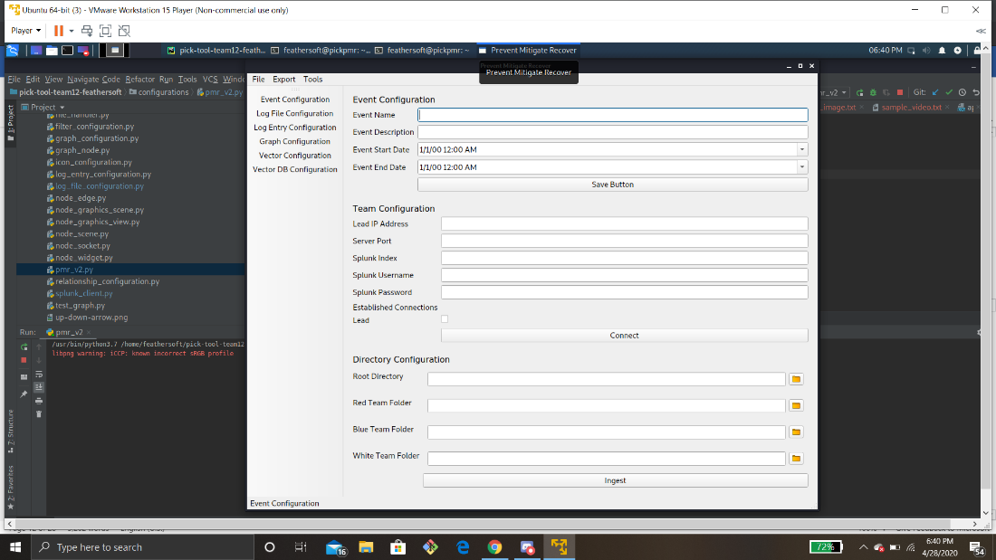

Figure 2.

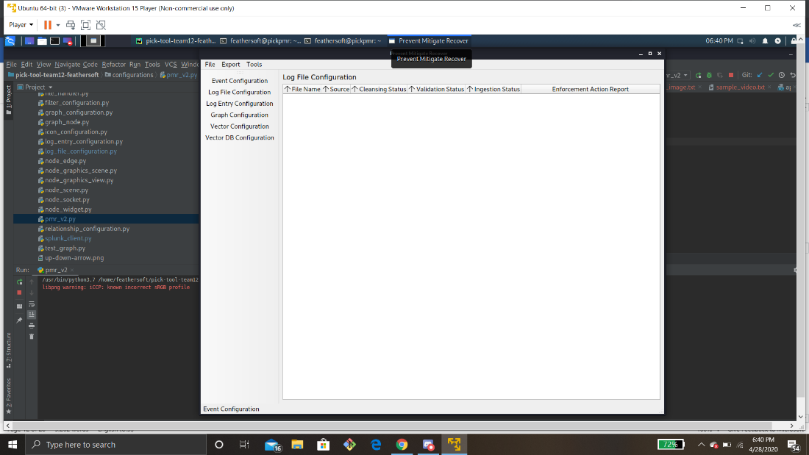

Figure 3.

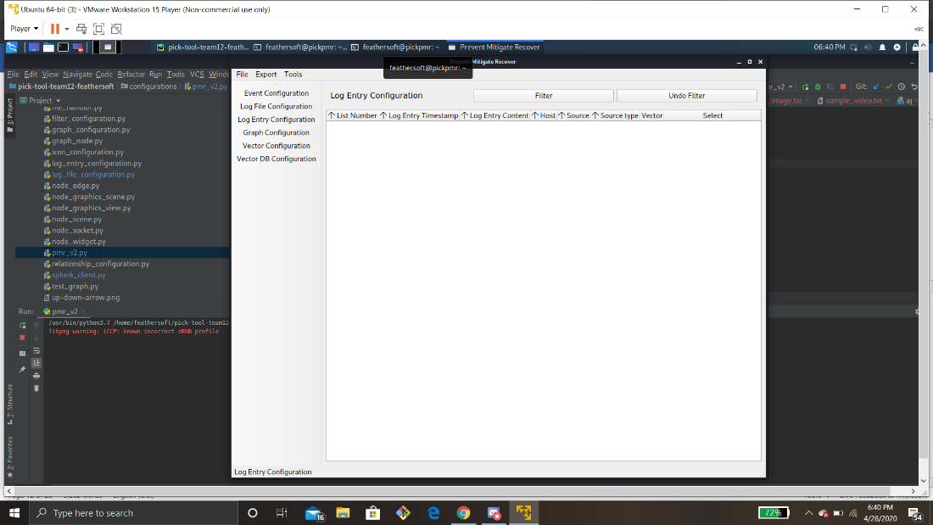

Figure 4.

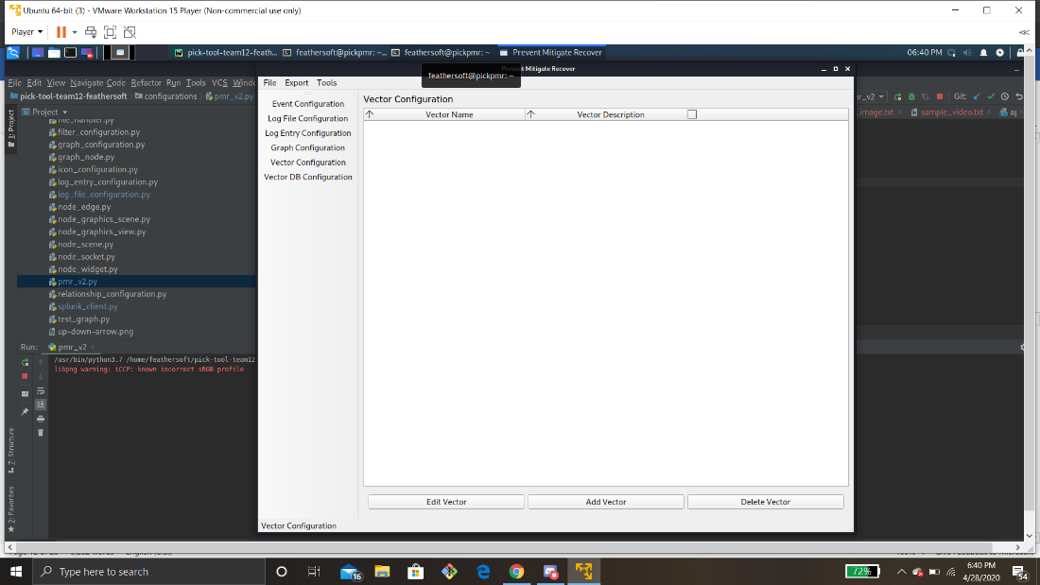

Figure 5.

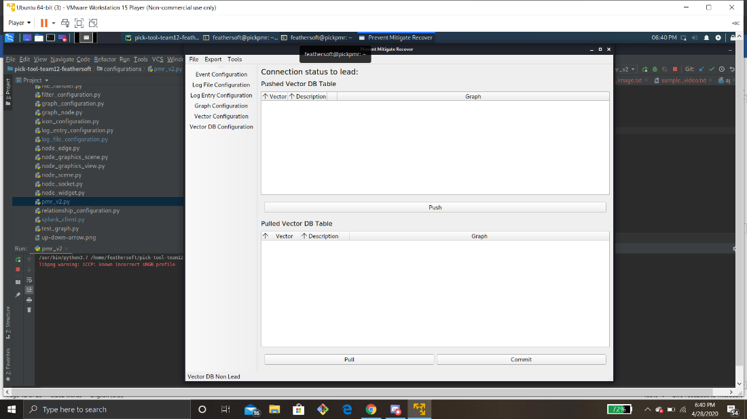

Figure 6.



